|  |  |
| --- | --- |
| Power BI Lab Day 5 Document | |
|  |  | | |
| **Writer:** | I&D Microsoft | | **Initials entity:** |
| **Date creation:** 26/04/2018 | |  | **Last upgrade:** 26/04/2018 |

Power BI LAB DOCUMENT

DAY 5– LAB 1

|  |  |  |  |  |
| --- | --- | --- | --- | --- |
| Version | Author | Comment | Reviewed By | Date |
| V 1.0 | I&D Microsoft | Initial draft | Moupiya Das |  |
|  |  |  |  |  |
|  |  |  |  |  |

**Pre-requisites**

* Installed and working Power BI Desktop setup.
* SQL Server with AdventureWorks Database.

**Environment Setup**

1. **Installing Power BI Desktop**

Power BI Desktop lets you create a collection of queries, data connections, and reports that can easily be shared with others. Power BI Desktop integrates proven Microsoft technologies – the powerful Query engine, data modeling, and visualizations – and works seamlessly with the online Power BI service. You will need to download and install Power BI desktop to perform the labs in this course.

* 1. **Which version to install?**

• If you have a 32 bit machine, you need to install the 32bit Power BI Desktop.

• If you have a 32 bit Office installed (regardless of your machine), you need to install the 32 bit Power BI Desktop.

• Otherwise, you can install the 64 bit PBI Desktop.

**1.2 Minimum requirements**

• Windows 7 / Windows Server 2008 R2, or later

• .NET 4.5

• Internet Explorer 9 or later

**1.3 Download and install Power BI Desktop**

You can download and install the latest version of Power BI Desktop in two ways,

1. Directly from Microsoft link, http://go.microsoft.com/fwlink/?LinkID=521662

**Note: To select which version to download, go to** [https://www.microsoft.com/en-us/download/details.aspx?id=45331](https://www.microsoft.com/en-us/download/details.aspx?id=45331%20) and select appropriate version.

2. Or, from Power BI Service site, <https://app.powerbi.com/>, i.e., in Power BI, click the Downloads > **Power BI Desktop**.



1. **Signing Up for Power BI Service**
2. Browse to [powerbi.com](https://powerbi.microsoft.com/).
3. Select **Start Free** or **Sign up free**.

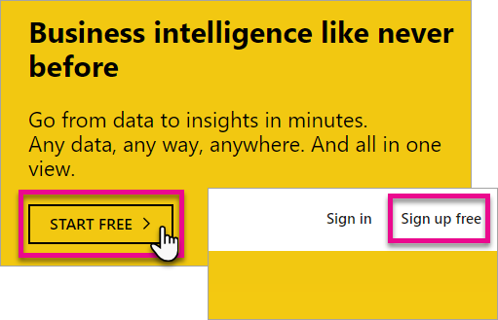

1. On the get started page, select **Try Free >** under Power BI.

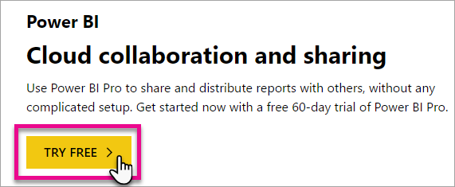

1. Enter the email address you are signing up with, and then select **Sign up**. Be sure your email address is allowed for sign up. For more information about what email address you can use, see [What email address can be used with Power BI.](https://docs.microsoft.com/en-us/power-bi/service-self-service-signup-for-power-bi#what-email-address-can-be-used-with-power-bi)

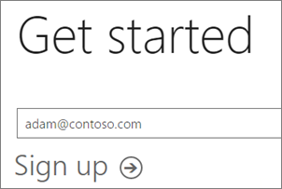

1. You will get a message indicating to check your email.

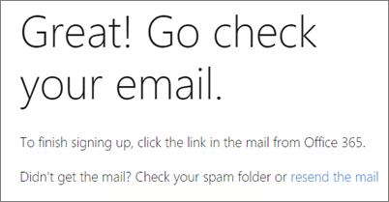

1. Select the link within the email to verify your email address. This will bring you back into the sign up flow. You may need to supply some additional information about yourself.
2. You will then be taken to [https://app.powerbi.com](https://app.powerbi.com/) and you can begin using Power BI as a free user.

SQL SERVER:

**Prerequisite: SQL Server with AdventureWorks Database.**

**Lab Overview**

This lab comprises of below task:

1. Import Data using Import Query mechanism.
2. Import Data using Direct Query mechanism.
3. App Workspace
4. Publish Report on PowerBI Service and Create Dashboard
5. Manual Refresh
6. Republish Report
7. Sharing Dashboard
8. Mobile Layout

**Case Scenario**

Import Data from SQL Server through Import Query.

# Import Data using Import query mechanism

1. Start with a blank Power BI Desktop file.
2. Click on Get Data option in the ‘Home’ tab.
3. Click on SQL Server.

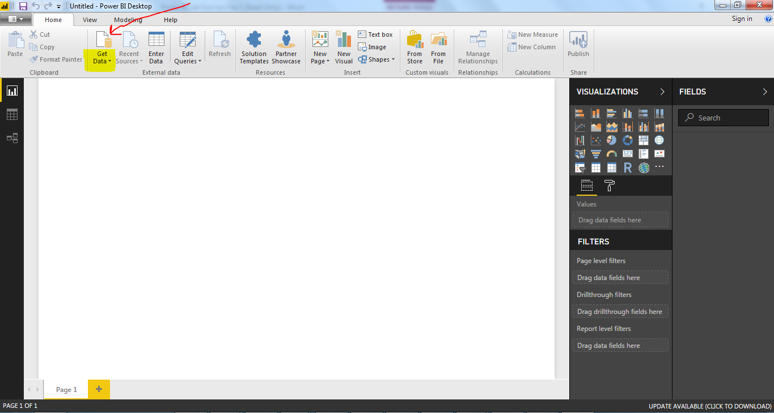

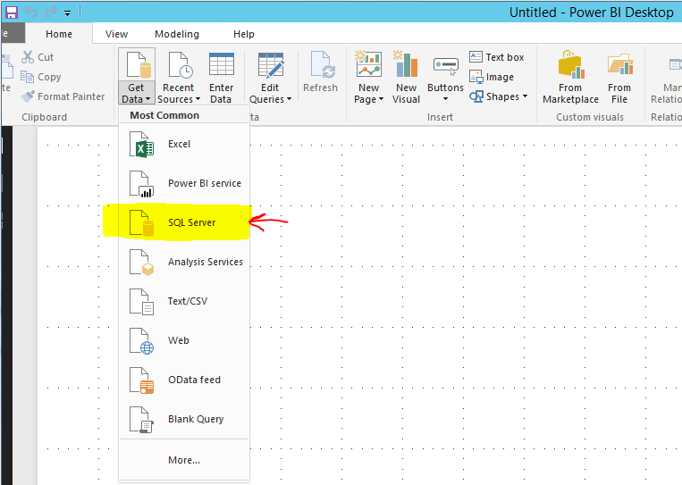

4. Data Import

There are two ways of importing data:

* Import
* Direct

Import Query:

* Click on Import Query.
* Mention Server and Database. List of tables would be rendered.
* Choose a table which will be source of dataset.

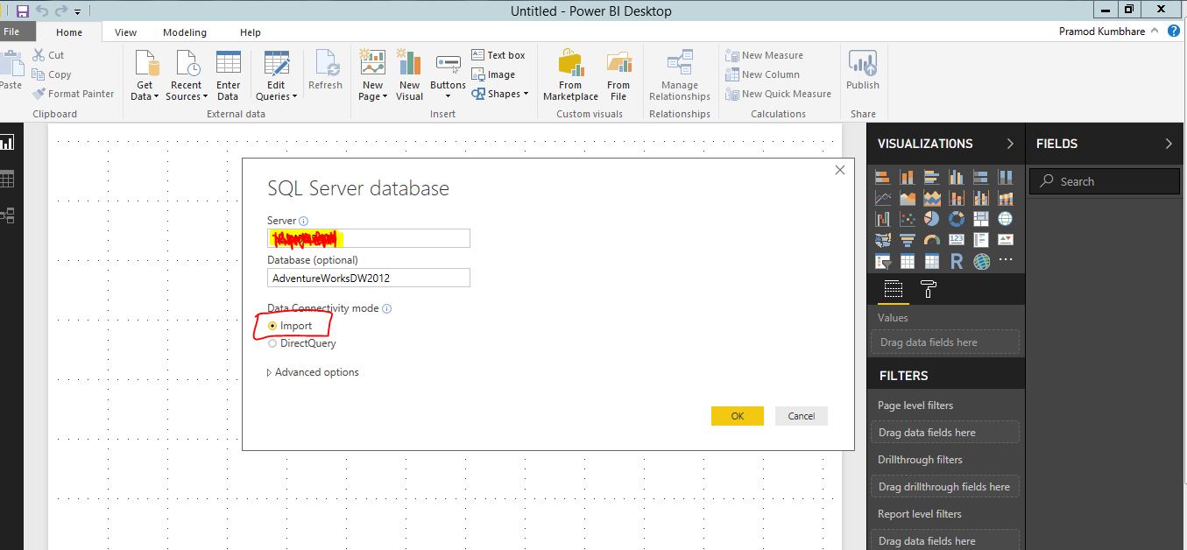

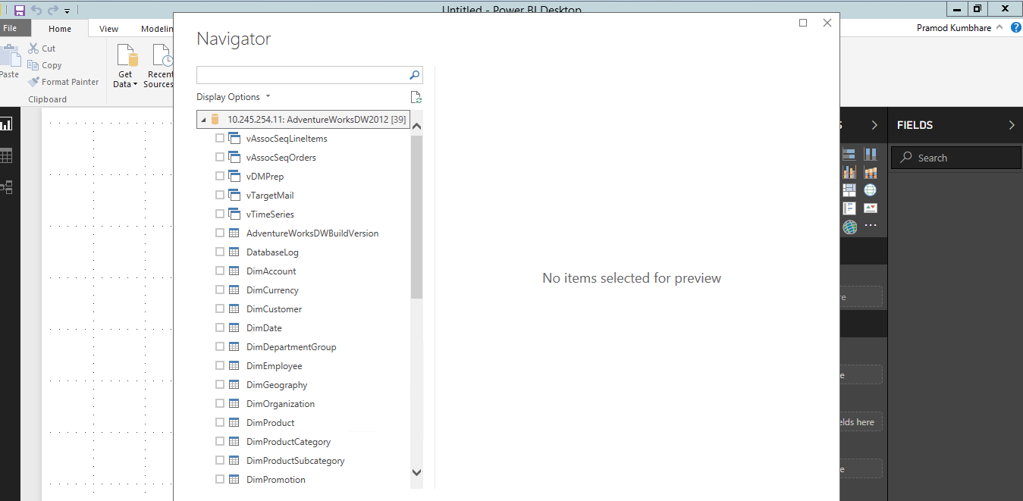

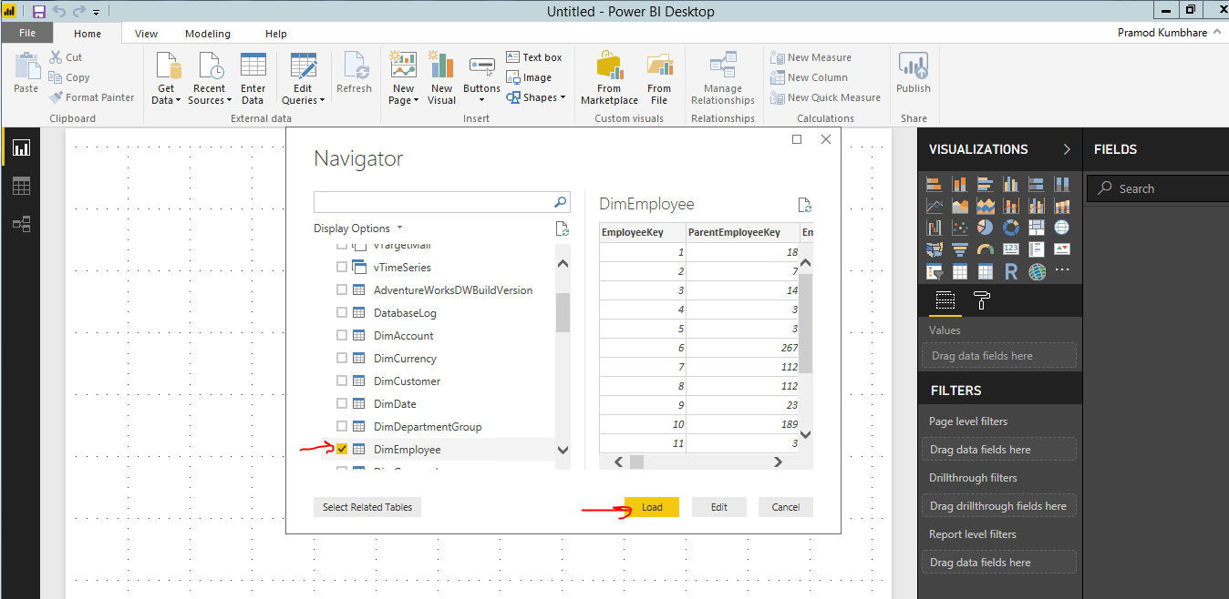

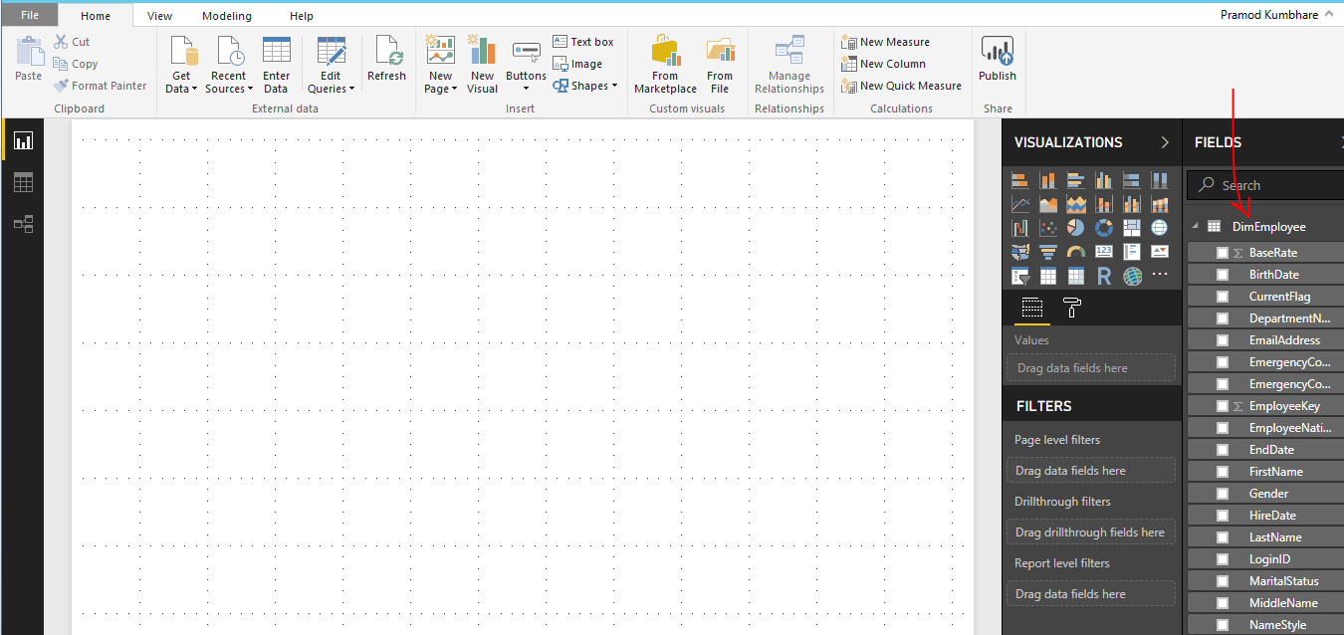

**Save the report with name “Day 5 – Lab 1 - <Trainee’s Name>.pbix”**

# Import Data-Direct Query mechanism

**Case Scenario**

Import Data from SQL through Direct Query.

1. Start with a blank Power BI Desktop file.

2. Click on Get Data option in the ‘Home’ tab.

3. Click on SQL Server.





4. Data Import

There are two ways of importing data:

* Import
* Direct

Direct Query:

* Click on Import Query.
* Mention Server and Database.

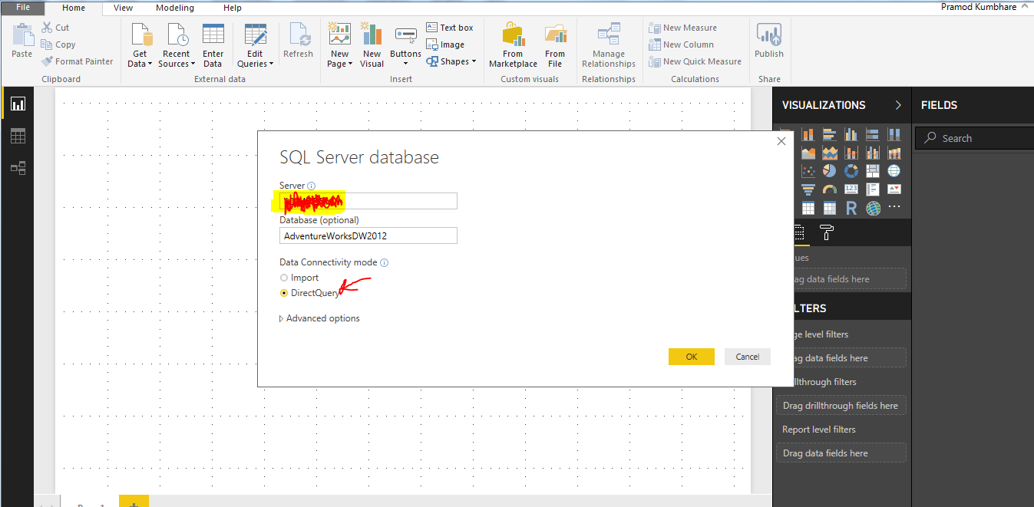





**Save the report with name “Day 5 – Lab 2 - <Trainee’s Name>.pbix”**

# 3. Create App Workspace

**Case Scenario**

Create App Workspace and share with Trainer.

1. Click on Workspaces and “Create app workspace”

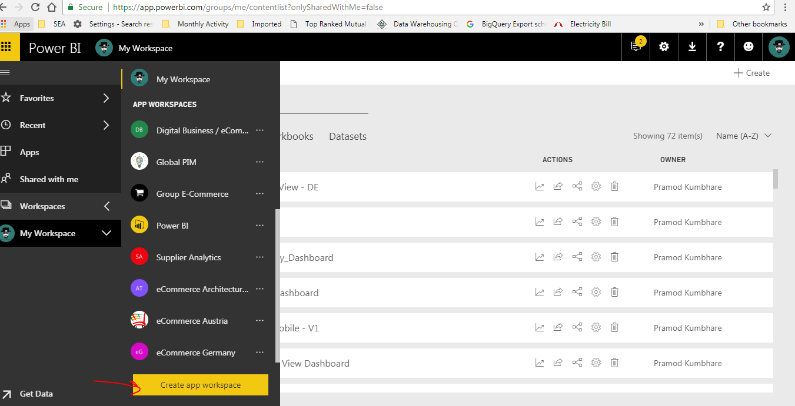

2. Fill in all the required fields –Name, Privacy

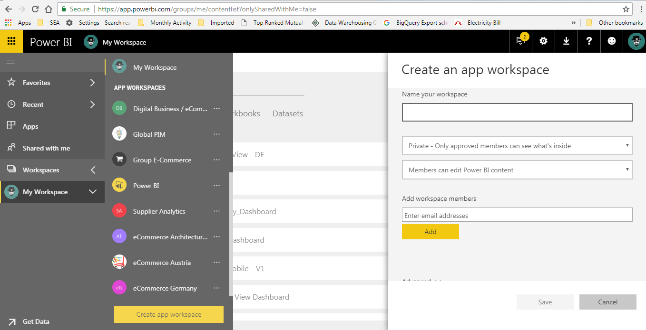

3. Add Workspace Member-Add trainer to member

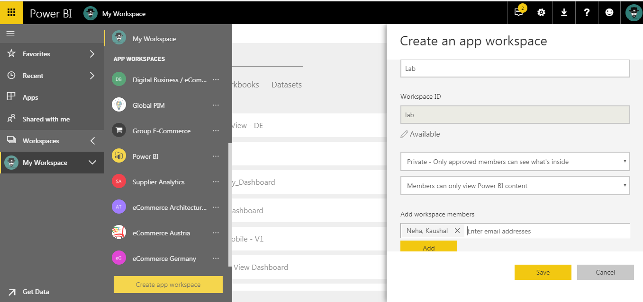

4. Save

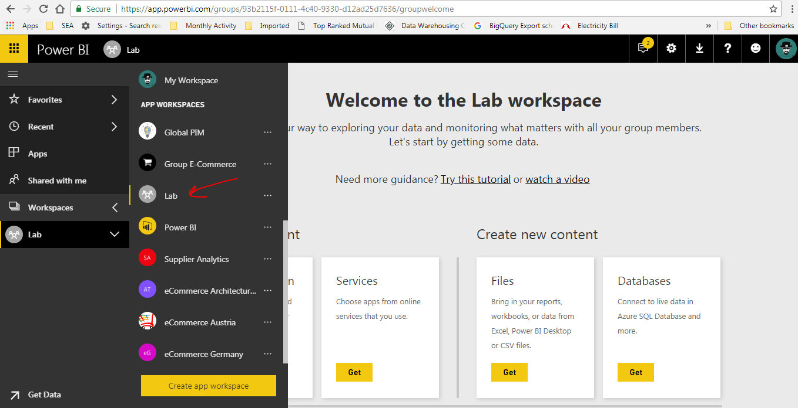

# 4. Publish Report on Power BI Services and Create Dashboard

**Case Scenario**

Create a basic report and publish it to Workspace and pin the visual to new dashboard.

1. Create a report with a pie chart visuals, as below screeshot.

2. Save the report with Name “Day 5 – Lab 4 - <Trainee’s Name>.pbix”.

3. Click on Publish

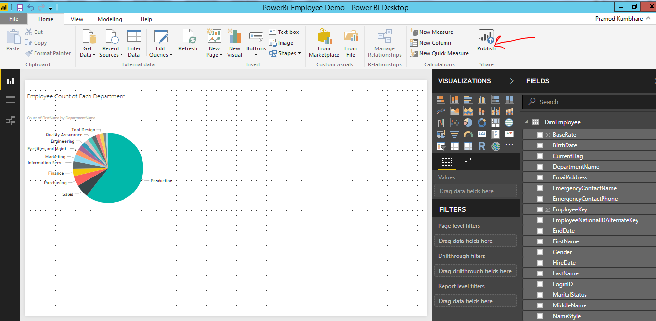

4. Select the workspace created in Day 5 Lab 3.

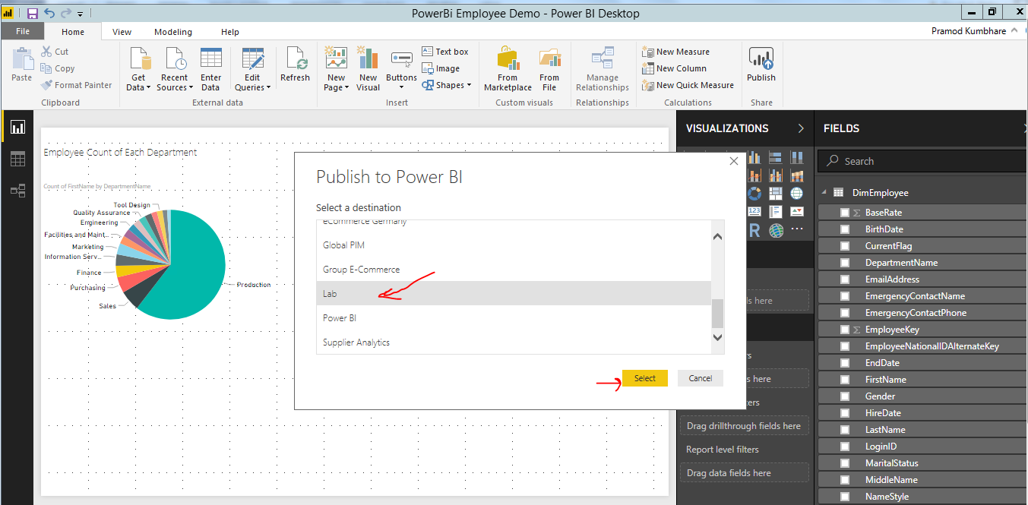

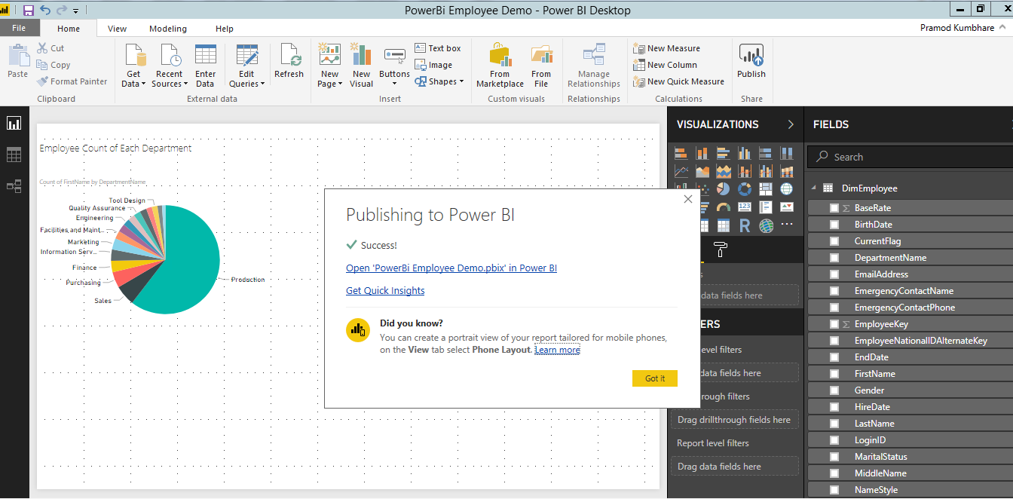

Once your report is successfully published on Workspace you will get notification as below.

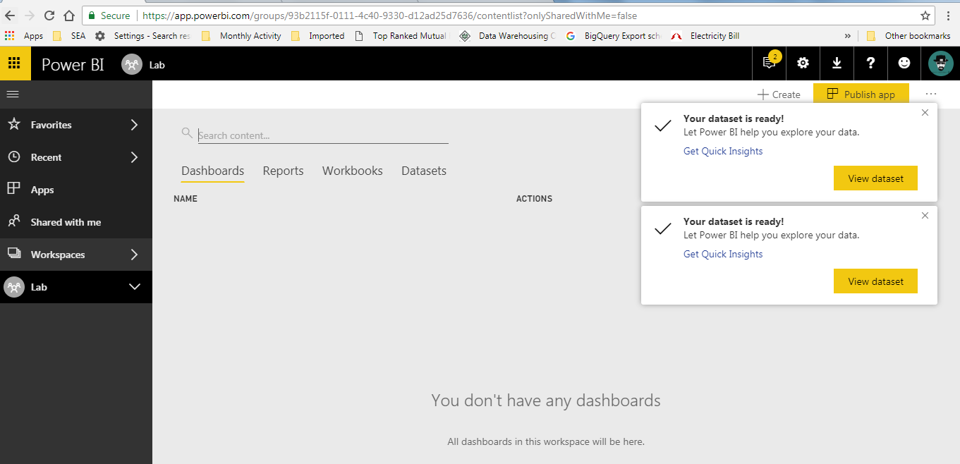

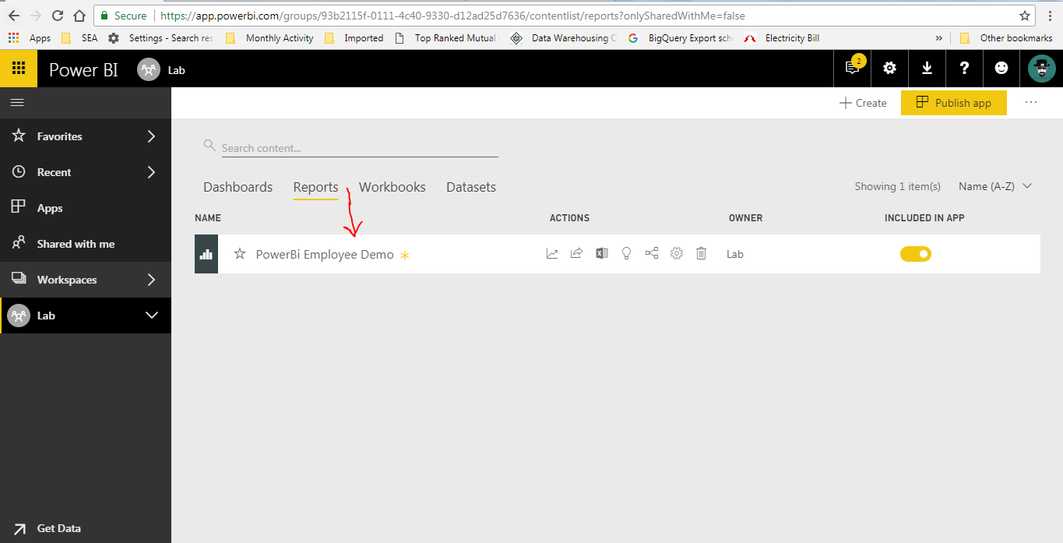

**Create Dashboard:**

1. Open the report published in Step 4.

2. Pin the visual to new Dashboard “Training_Dashboard_<Trainee’s Name>”.

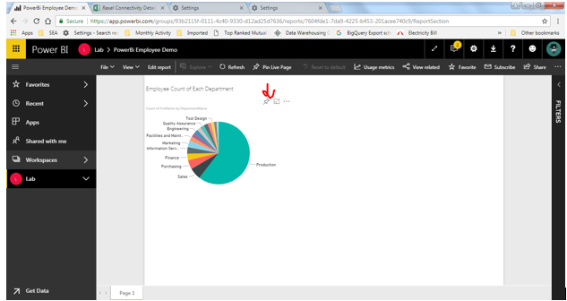

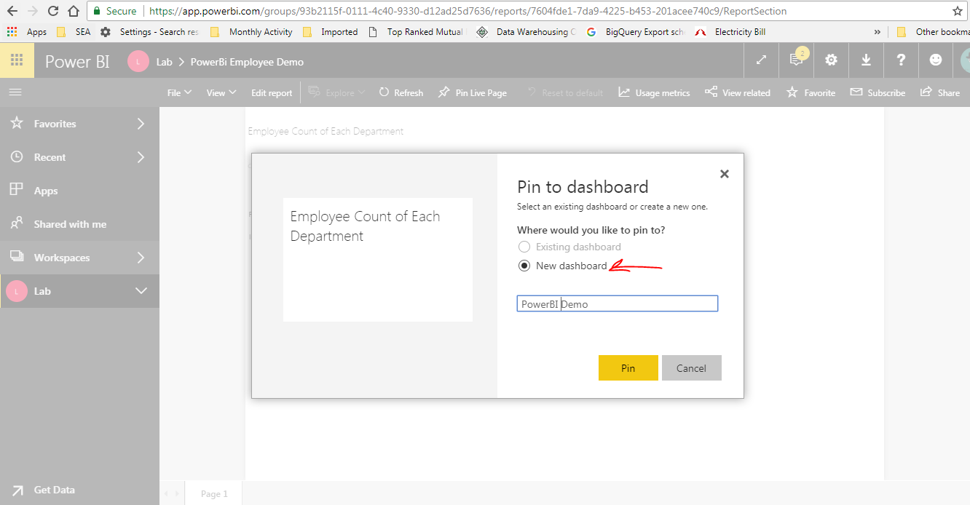

4. Click on Dashboard Visual and it will navigate to report.

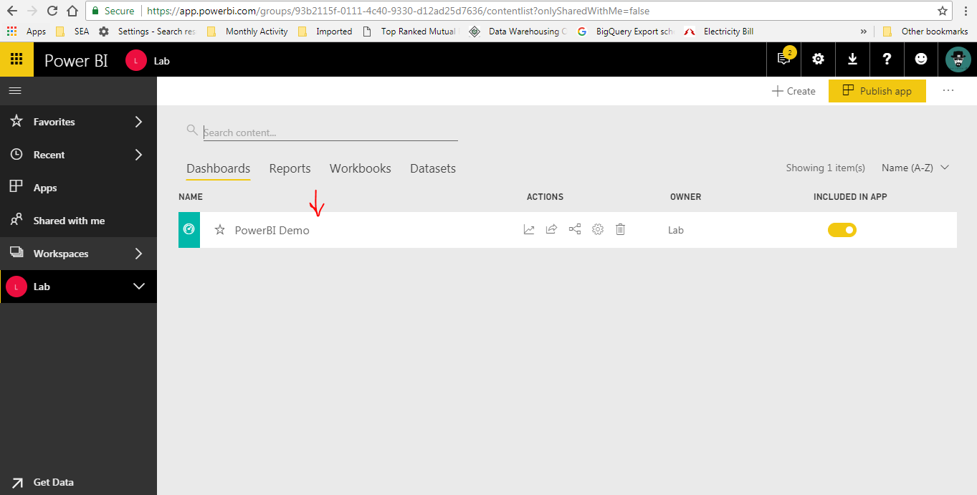

# 5. Manual Refresh

**Case Scenario**

Refresh report data manually.

1. Click on Refresh in PowerBI Desktop Report.

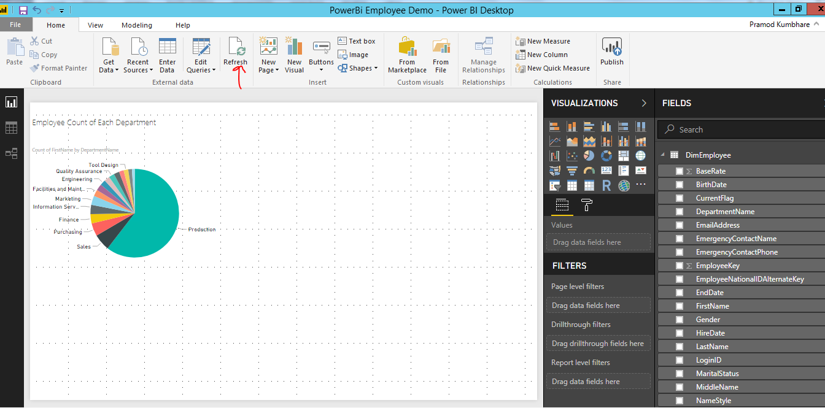

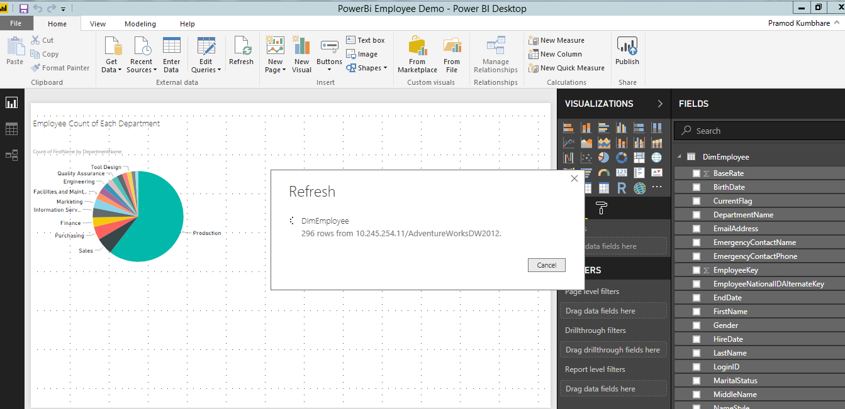

# Schedule Refresh

Scheduled Refresh: Trainer will demo this (will not be part of Lab session) as it will require PowerBI Pro license and Enterprise Gateway setup.

# 6. Republish Report

**Case Scenario**

Republish report to workspace.

Re-Publish:





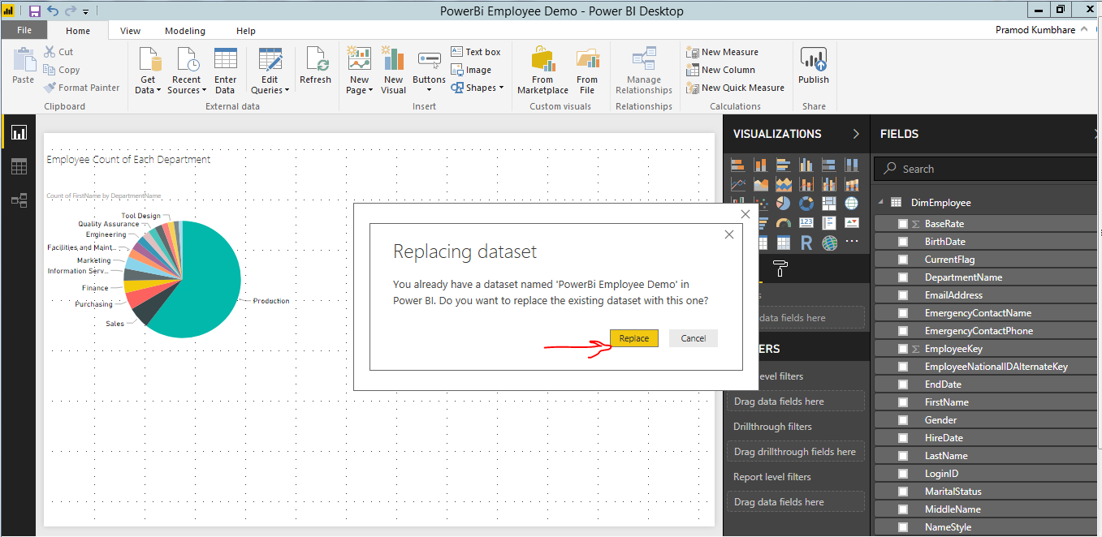



# 7. Share Dashboard

**Case Scenario**

Share Dashboard with trainer created in Lab 4.

1. Click on the Dashboard and navigate to report and click on Share.

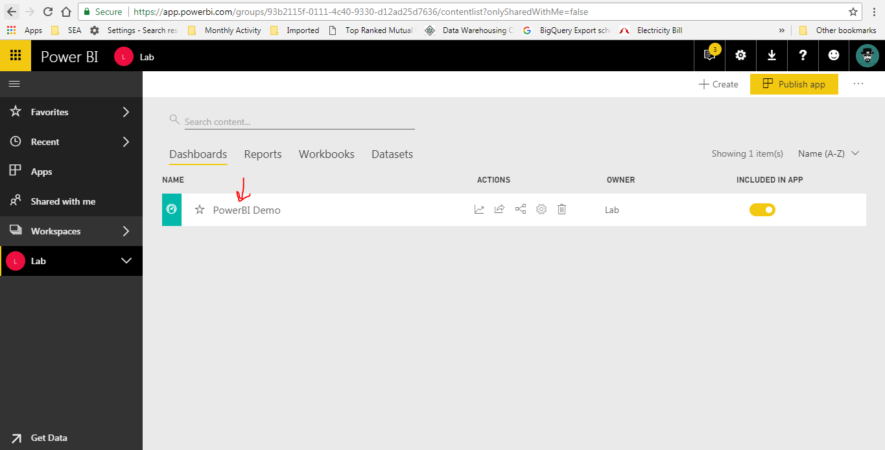

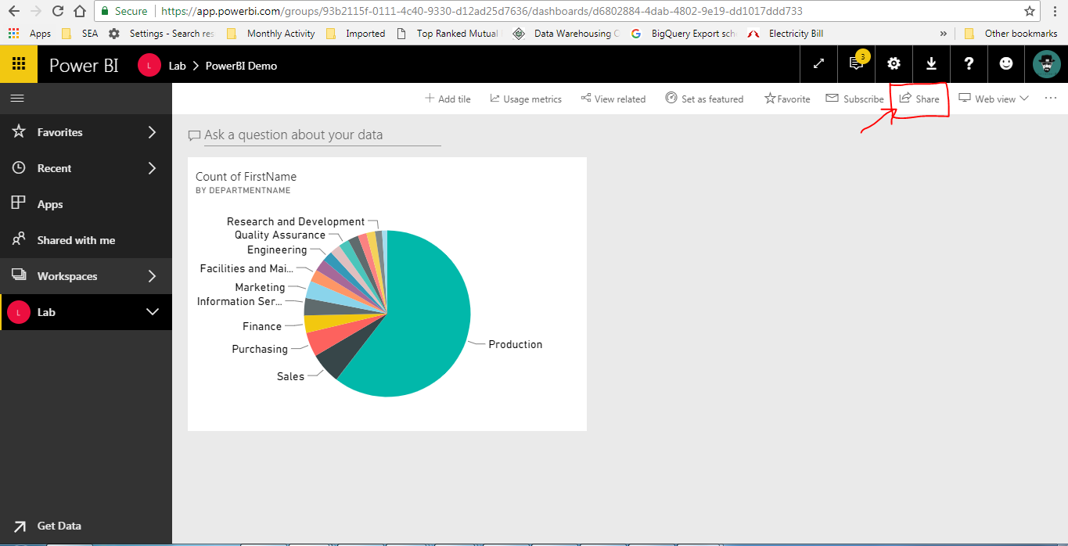

1. Add trainer’s email in “Grant Access To” and uncheck Allow Recipients to share your dashboard.

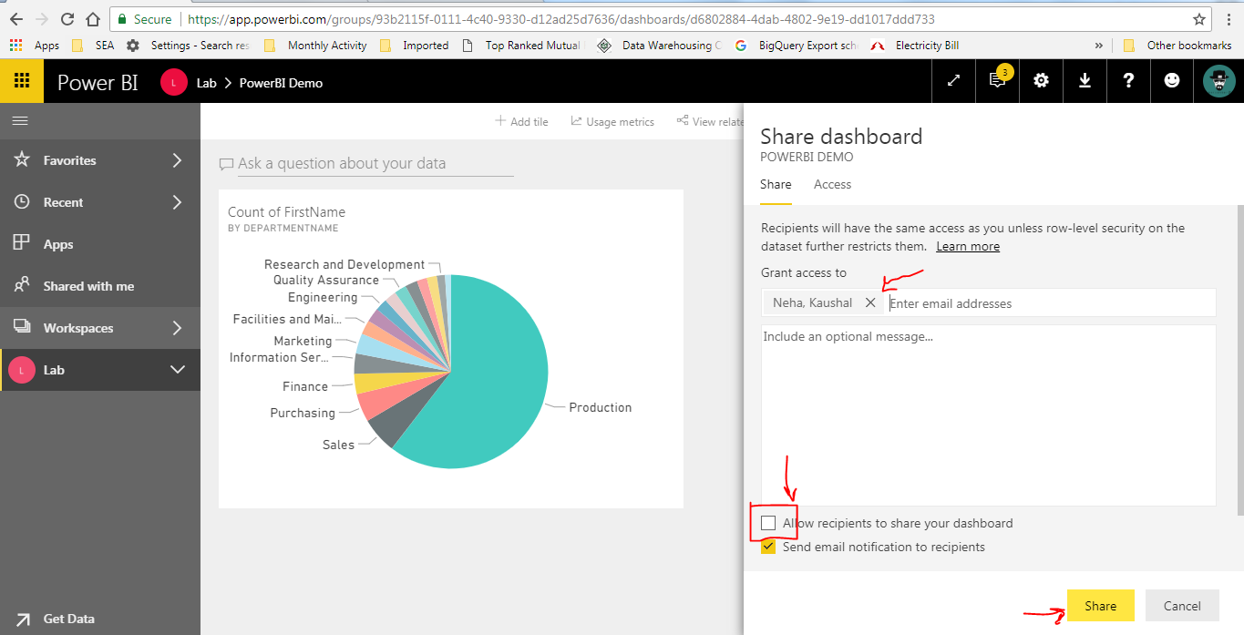

1. Click Share.

# 8. Mobile Report

1. Create a report with Page View Layout.

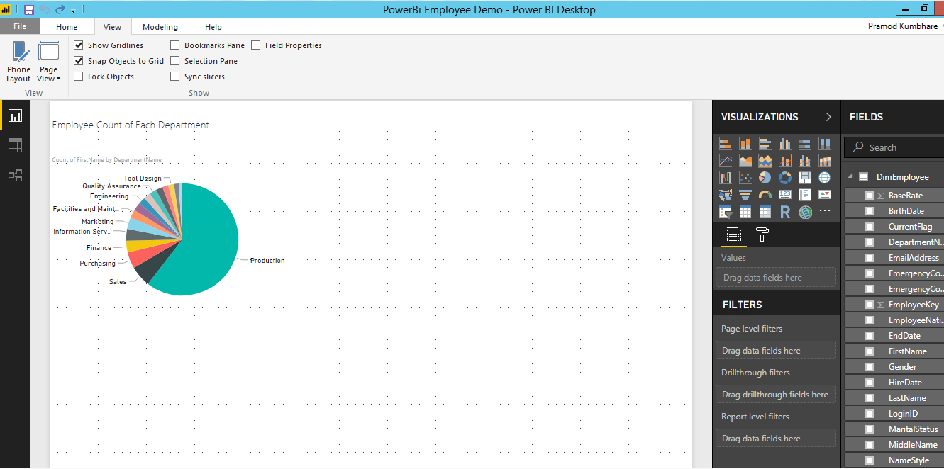

1. Save the Report.
2. Click on Phone Layout.

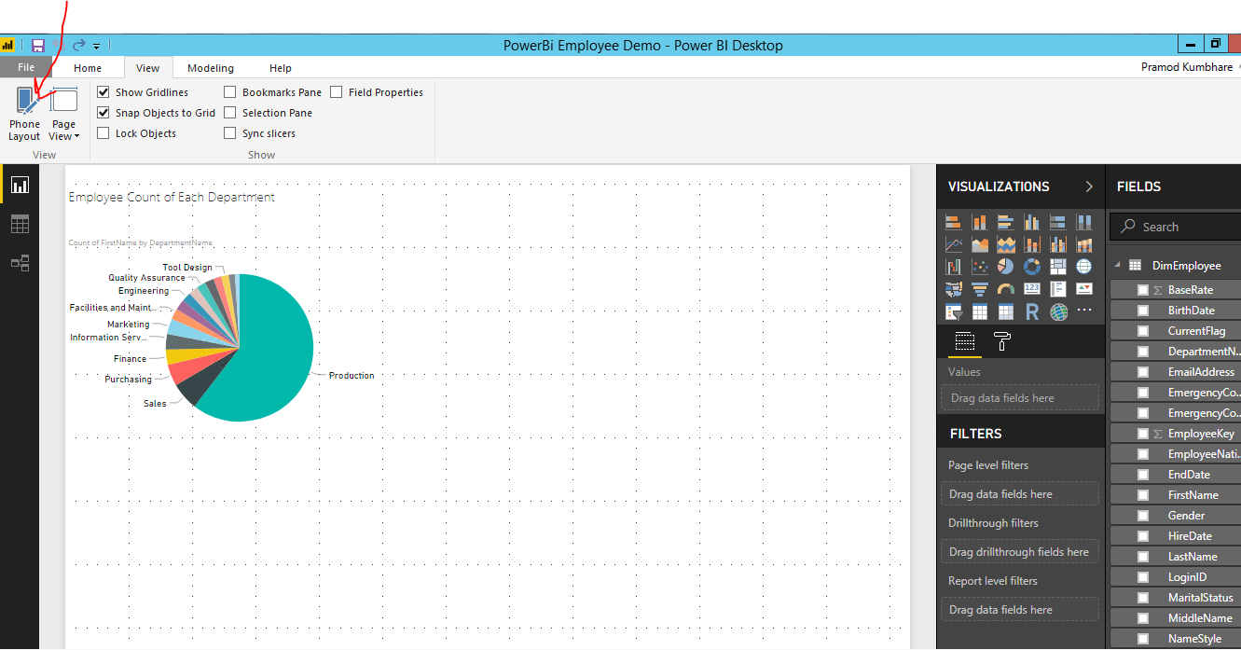

1. Drag the report visuals.

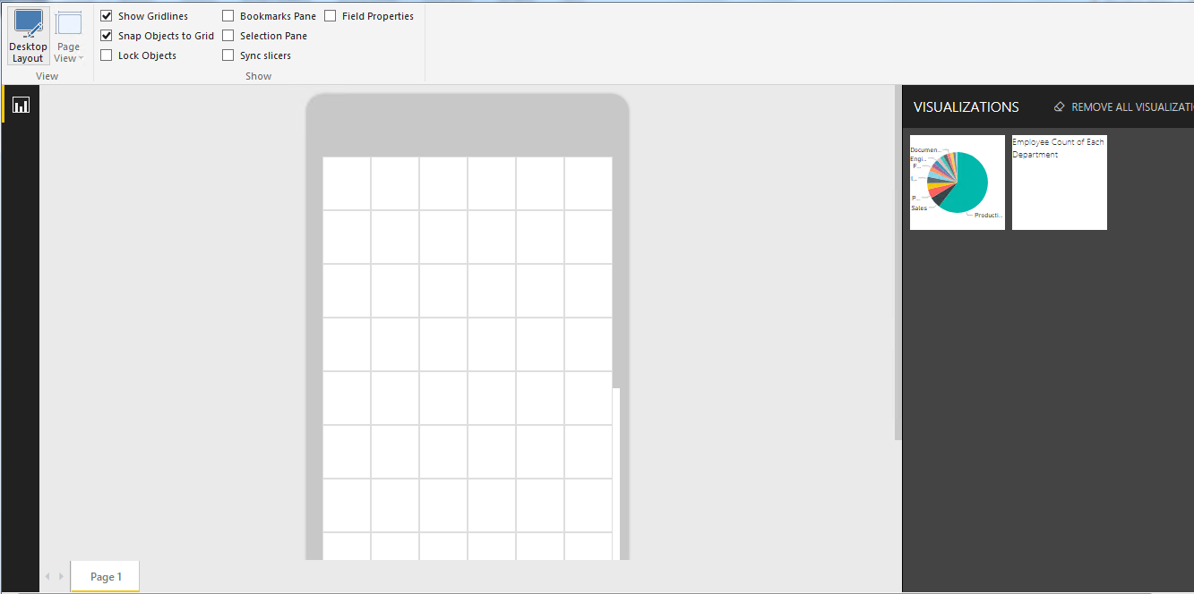

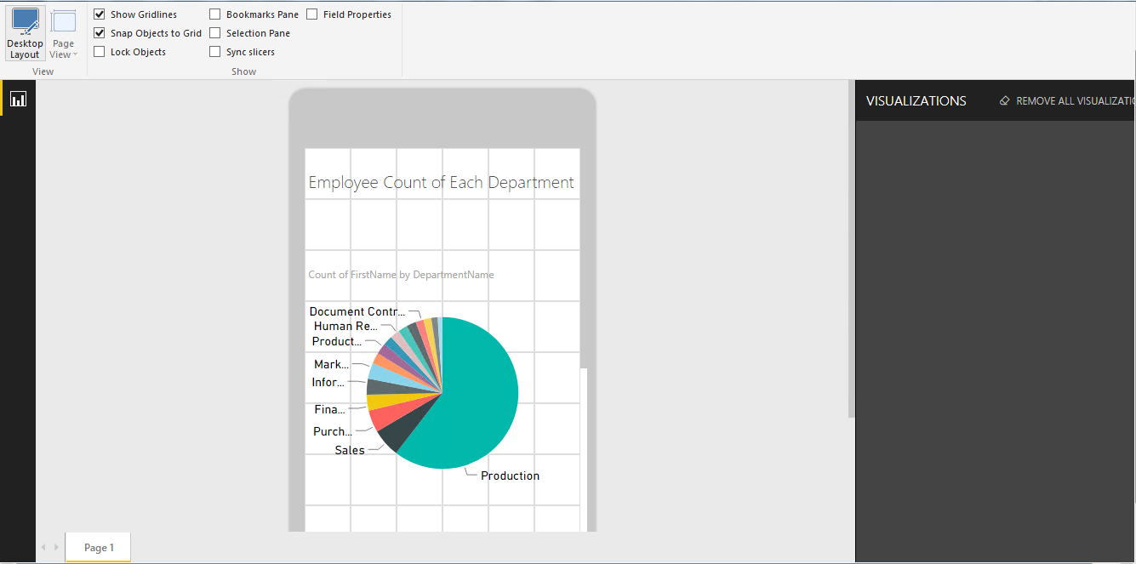

1. Save the Report and Publish.

# Mobile Dashboard

1. Go to Dashboard created in Lab 4.
2. Click on Phone View.

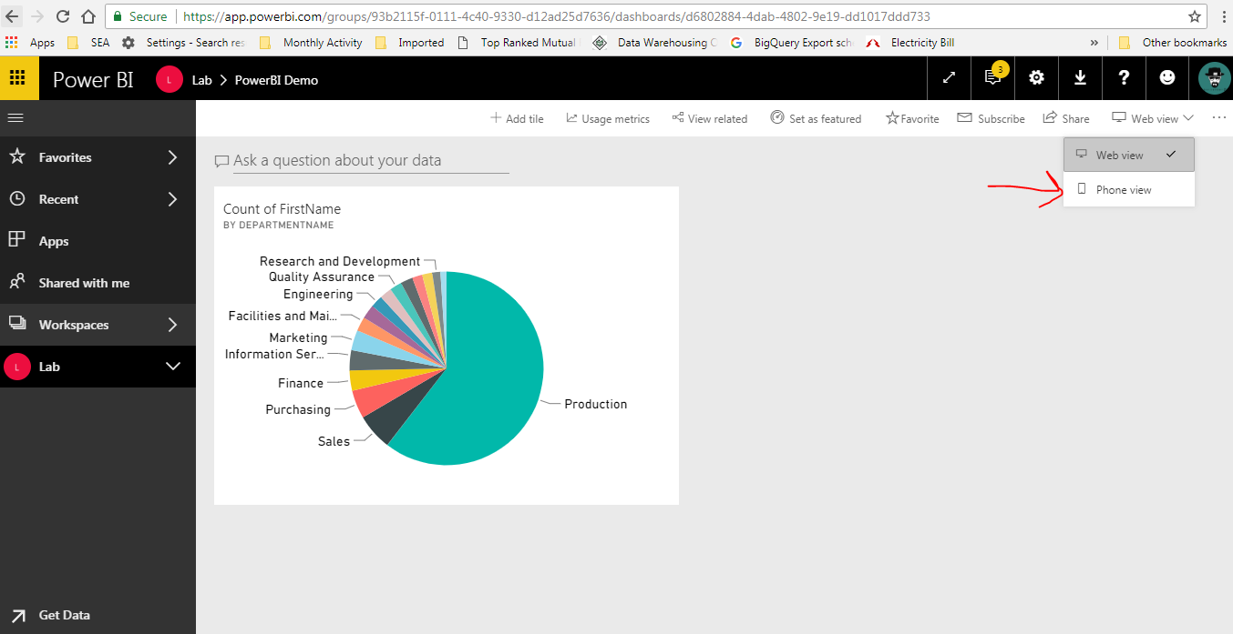

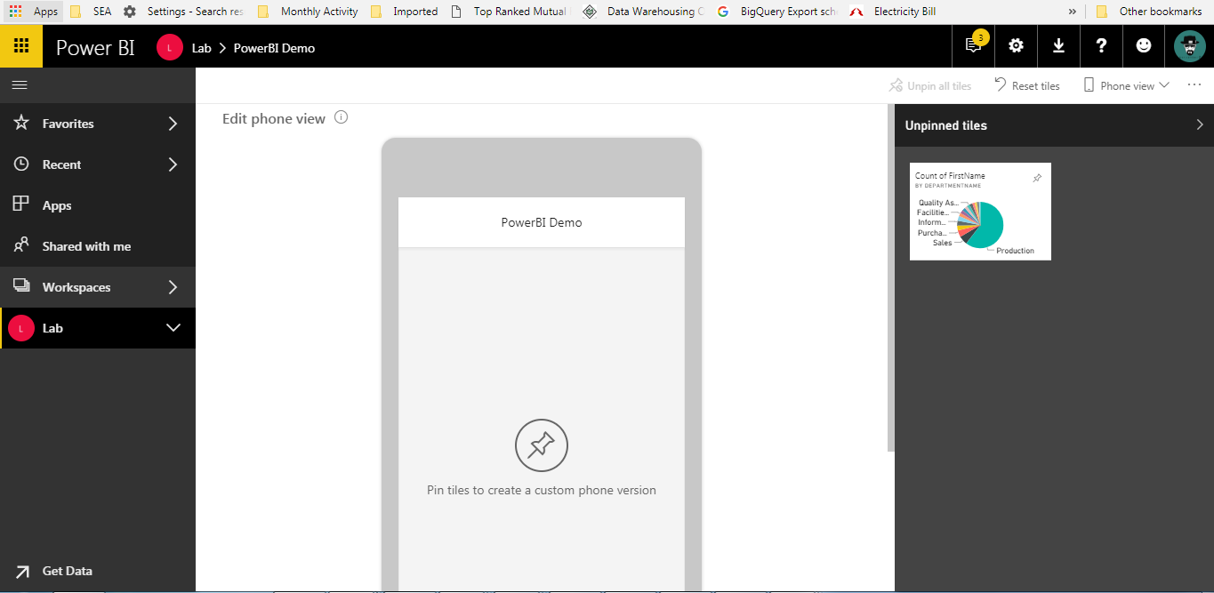

3. Pin the visual.

